Can you help children get a Sporting Chance?

The Parent Community Sports (PCST) trust is a charity founded by parents to develop sport activities and develop facilities. We believe that not enough children are playing sport and we are concerned about the health and well-being of our young people.

You can help us prevent childhood obesity and diabetes by helping us create opportunities to play sport.
You can help children get the benefits of being a team player and making lifelong friendships though sport.

What we do

We encourage parent lead sports initiatives in local communities. Helping them run local teams for local children. We send sports coaches into local schools helping children stay fit and healthy

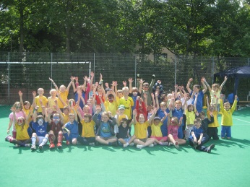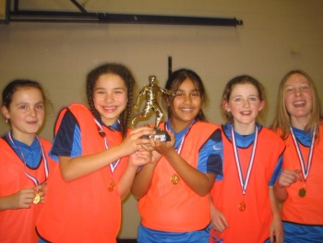

How can you help us?
If you would like to help us we would welcome a one off donation or you can make a monthly contribution through direct debit.

To Donate:
Send us a donation. Please make a cheque out to PCST and enclose in the envelope provided.
Set up a monthly donation please complete the mandate below:
I would like to donate (tick box) towards the work of PCST
£5 |  | £10 |  | £15

Name
Address
Post Code
Contact Telephone Number
Email
Sort Code
Account Number
Signature
Date

PCST is a registered charity in Scotland SCO44806
Registered Office: 38 Beechwood drive, Glasgow, G11 7EX

